Experiment No.: 01
Experiment Name: Taking two number inputs and showing output
Code:
.MODEL SMALL
.STACK 100H
.DATA
.CODE
MAIN PROC
MOV AH,1
INT 21H
MOV BL,AL

MOV AH,2
MOV DL,'+'
INT 21H
MOV AH,1
INT 21H
ADD BL,AL

SUB BL,'0'
MOV AH,2

MOV DL,'='
INT 21H

MOV DL,BL
INT 21H

MOV AH, 4CH
INT 21H
MAIN ENDP
END MAIN

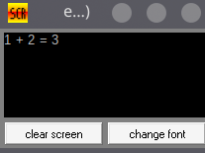
Output:
Discussion:
The Program successfully inputs two numbers and outputs their sum. However, the input is actually taken as character. So, we must modify the final output by subtracting the value of ‘0’. The program however only works up until the sum is less than 10.

Experiment No.: 01
Experiment Name: Convert a lower-case letter to an upper-case letter
Code:
.MODEL SMALL
.STACK 100H
.DATA
CR EQU 0DH
LF EQU 0AH
MSG1 DB 'ENTER A LOWER CASE LETTER: $'
MSG2 DB CR, LF, 'IN UPPER CASE IT IS: '
CHAR DB ?, '$'
.CODE
MAIN PROC

MOV AX, @DATA
MOV DS, AX
LEA DX, MSG1
MOV AH, 9
INT 21H

MOV AH, 1
INT 21H
SUB AL, 20H
MOV CHAR, AL

LEA DX, MSG2
MOV AH, 9
INT 21H

MOV AH, 4CH
INT 21H
MAIN ENDP
END MAIN

Output:
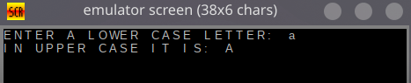

Discussion:
A simple input is given in small letter, and the output is properly shown in a new line which is the desired capital letter.
Experiment No.: 02
Experiment Name: Showing the decimal value of Hex numbers(A to F)
Code:
.MODEL SMALL
.STACK 100H
.DATA
.CODE
MAIN PROC

MOV AX, @DATA
MOV DS, AX

MOV AH,1
INT 21H
MOV BL,AL

MOV AH,2
MOV DL, ' '
INT 21H

MOV DL,'1'
INT 21H

SUB BL,'A'
ADD BL,'0'
MOV DL,BL
INT 21H

MOV AH, 4CH
INT 21H
MAIN ENDP
END MAIN

Output:
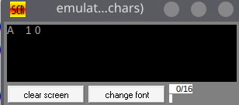

Discussion:
The program takes Hex inputs from ‘A’ to ‘F’ and shows the corresponding decimal output. The ‘1’ is prewritten and we compare with ‘A’ to determine the 2nd digit.

Experiment No.: 01
Experiment Name: Input three letters while checking for correctness and whether they are capital letters and output them in an ascending order in lower-case
Code:
.MODEL SMALL
.STACK 100H
.DATA
A DB ?
B DB ?
C DB ?
E DB 'ERROR!$'

.CODE
MAIN PROC
MOV AX,@DATA
MOV DS,AX

MOV AH,1

INT 21H
MOV CL,AL

INT 21H
MOV BL,AL

INT 21H

CMP AL,'A'
JL ERROR
CMP AL,'Z'
JG ERROR

CMP BL,'A'
JL ERROR
CMP BL,'Z'
JG ERROR

CMP CL,'A'
JL ERROR
CMP CL,'Z'
JG ERROR

COMPARE_AB:
CMP AL,BL
JL COMPARE_BC
XCHG AL,BL;BL IS NOW BIGGER

COMPARE_BC:
CMP BL,CL
JL COMPARE_AB_2
XCHG CL,BL;CL IS NOW BIGGER

COMPARE_AB_2:
CMP AL,BL
JL PRINT
XCHG AL,BL;BL IS NOW BIGGER

PRINT:
MOV A,AL
MOV AH,2
ADD A,32
MOV DL,A
INT 21H
ADD BL,32
MOV DL,BL
INT 21H
ADD CL,32
MOV DL,CL
INT 21H
JMP ENDING
ERROR:
MOV AH,9
LEA DX, E
INT 21H

ENDING:
MAIN ENDP
END MAIN

Output:
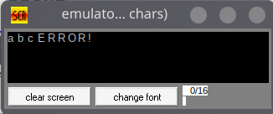
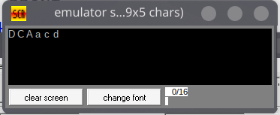

Discussion:
The program successfully checks the inputs for errors and prints the output in an ascending manner as well as in lower-case.
Experiment No.: 01
Experiment Name: Odd-Even checking with switch-case and error checking
Code:
.MODEL SMALL
.STACK 100H
.DATA
E DB 10,13,'EVEN',10,13,'$'
O DB 10,13,'ODD',10,13,'$'
D DB 10,13,'DECIMAL:','$'
ERR DB 10,13,'WRONG INPUT SELECT Y/N',10,13,'$'
ASK DB 10,13,'INPUT_HEX: ','$'
ASK_AGAIN DB 10,13,'RECHECK: ','$'
.CODE
MAIN PROC
MOV AX,@DATA
MOV DS,AX

INPUT:
MOV AH,9
LEA DX, ASK
INT 21H

MOV AH,1
INT 21H

MOV BL, AL
MOV AH,9
LEA DX,D
INT 21H
MOV AL,BL

CMP BL,'A'
JL PRINT
SUB BL,'A'
ADD BL,'0'

MOV AH,2
MOV DL,'1'
INT 21H

PRINT:
MOV AH,2
MOV DL,BL
INT 21H

CHECK_1:
AND BL,1
CMP BL,1
JNE EVEN
MOV AH,9
LEA DX,O
INT 21H
JMP CHECK_2
EVEN:
MOV AH,9
LEA DX,E
INT 21H
CHECK_2:
MOV AH,9
LEA DX, ASK_AGAIN
INT 21H
MOV AH,1
INT 21H

CMP AL,'Y'
JE INPUT
CMP AL,'y'
JE INPUT

CMP AL,'N'
JE END
CMP AL,'n'
JE END

MOV AH,9
LEA DX, ERR
INT 21H
JMP CHECK_2

END:
MOV AH,4CH
INT 21H
MAIN ENDP
END MAIN

Output:
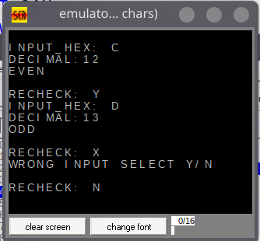

Discussion:
The program takes a Hex input from 0 to ‘A’, properly outputs the decimal value and finally shows whether it’s odd or even based on AND operation.

Experiment No.: 01
Experiment Name: Binary Input-Output, Reversal, Compliment and Odd Parity Check
Code:
.MODEL SMALL
.STACK 100H
.DATA
ORIG DB ?
COMP DB ?
REV DB ?
ODD DB ?
TEMP DB ?

.CODE

MAIN PROC
MOV AX,@DATA
MOV DS,AX

MOV BL,0
MOV AH,1
MOV CX,8
INPUT:
INT 21H
SUB AL,'0'
SHL BL,1
OR BL,AL
LOOP INPUT
JMP COMPLEMENT
COMPLEMENT:
MOV DL,BL
MOV ORIG,BL
XOR DL, 11111111B
MOV COMP,DL

MOV CX,8
MOV AL,0
REVERSE:
MOV TEMP,1
AND TEMP,DL
ROR DL,1
SHL AL,1
OR AL,TEMP
LOOP REVERSE
MOV REV,AL
MOV CX,4
MOV DH,0
PARITY:
MOV TEMP,1
AND TEMP, AL
SHR AL,1
XOR DH,TEMP
LOOP PARITY
XOR DH,1
MOV ODD,DH

END:
MOV AH,2

MOV CX,8
MOV DL,10
INT 21H
MOV DL,13
INT 21H
MOV BL,ORIG
LOOP1:
MOV TEMP,10000000B
AND TEMP,BL
ROL BL,1
ROL TEMP,1
ADD TEMP,'0'
MOV DL,TEMP
INT 21H
LOOP LOOP1

MOV CX,8
MOV DL,10
INT 21H
MOV DL,13
INT 21H
MOV BL,COMP
LOOP2:
MOV TEMP,10000000B
AND TEMP,BL
ROL BL,1
ROL TEMP,1
ADD TEMP,'0'
MOV DL,TEMP
INT 21H
LOOP LOOP2

MOV CX,8
MOV DL,10
INT 21H
MOV DL,13
INT 21H
MOV BL,REV
LOOP3:
MOV TEMP,10000000B
AND TEMP,BL
ROL BL,1
ROL TEMP,1
ADD TEMP,'0'
MOV DL,TEMP
INT 21H
LOOP LOOP3

MOV DL,10
INT 21H
MOV DL,13
INT 21H
MOV BL,REV

MOV DL,ODD
ADD DL,'0'
INT 21H

MOV AH,4CH
INT 21H
MAIN ENDP
END MAIN

Output:

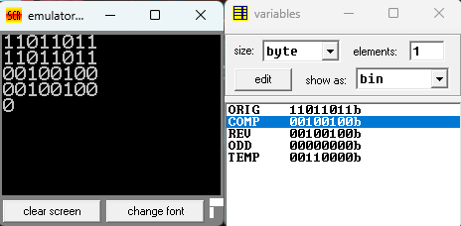

Discussion:
The program-
- Took ascii input of 0s and 1s and transformed into real binary code stored in the ORIG variable
- Performed 1’s compliment with bitwise arithmetic, which is showed in COMP variable
- Reversed the complimented value with SHL and RHL along with bitwise arithmetic and it is in REV variable.
- Lastly, we checked for odd parity which is 0 for this input in ODD.
Limitations-
- Some operations could have been simplified by using carry and RCL/RCR operations
- The use of auxiliary variables to store the result of bit-checking with AND could have been avoided with TEST opcode

